**MEDIMAPPER**

**TEAM MEMBERS:**

Mennalosani R G (Team Leader)

Abirami R

Ashwin K

Dharshini Nivetha M

**COLLEGE:**

Velalar College of Engineering and Technology

**PROJECT DESCRIPTION:**

The project aims to gather comprehensive patient data, leveraging machine learning algorithms to precisely identify and recommend prescribed medications. By integrating advanced data analytics techniques, the system ensures accurate medication predictions tailored to individual patient profiles. Through meticulous analysis of patient information the project facilitates personalized and efficient healthcare delivery. By harnessing the power of machine learning, the platform enhances prescription accuracy, minimizing the risk of errors and adverse reactions. Utilizing a data-driven approach, the project streamlines the medication process, optimizing treatment outcomes and patient care. With a focus on precision and reliability, the project endeavors to revolutionize the healthcare landscape by providing tailored medication recommendations based on extensive data analysis. Through seamless integration of machine learning technologies, the project empowers healthcare professionals to make informed decisions, ultimately improving patient outcomes and quality of care.

**APPROACH:**

The project begins by gathering patient datasets from Kaggle, leveraging this valuable resource for comprehensive data acquisition. With a focus on data understanding, the collected datasets undergo examination and visualization to glean insights and understand patterns within the data. Following this initial phase, data cleaning techniques are implemented to enhance the quality and reliability of the dataset. Through Exploratory Data Analysis (EDA), the project delves deeper into the dataset, uncovering correlations and trends that inform subsequent steps. Visualizations play a crucial role in understanding complex relationships and facilitating better comprehension of the dataset.

In the data preprocessing phase, the dataset is partitioned into training and testing subsets, a pivotal step in preparing the data for model selection. Model selection involves assessing different machine learning algorithms based on their training accuracy and cross-validation scores to identify the best model for the job. This iterative process ensures that the chosen model is well-suited to the dataset and capable of producing reliable predictions.

Finally, the development of a Streamlit application, providing a user-friendly interface for interaction with the model. This application enables users to input relevant data and receive instant feedback based on the model's predictions, thereby facilitating seamless integration of the model into practical healthcare settings. Through a systematic approach encompassing data collection, preprocessing, model selection, and application development, the project endeavors to harness the power of machine learning for enhanced patient care and treatment outcomes.

**LIBRARIES USED:**

**pandas:**

A powerful data manipulation library in Python, providing data structures and functions to work with structured data, such as DataFrame objects, for data analysis and manipulation tasks.

**numpy:**

A fundamental package for scientific computing with Python, offering support for large, multi-dimensional arrays and matrices, along with a collection of mathematical functions to operate on these arrays efficiently.

**matplotlib :**

A plotting library for the Python programming language, offering a wide variety of high-quality 2D plotting capabilities for generating static, interactive, and animated visualizations.

**seaborn:**

A data visualization library based on matplotlib, providing a high-level interface for drawing attractive statistical graphics, such as heatmaps, violin plots, and regression plots, to explore and understand complex datasets.

**sklearn:**

Scikit-learn is a versatile machine learning library in Python, offering simple and efficient tools for data mining and data analysis. It features various algorithms for classification, regression, clustering, dimensionality reduction, and model selection, along with tools for model evaluation and preprocessing.

**Scipy:**

A library for scientific computing and technical computing in Python, providing functions for numerical integration, interpolation, optimization, linear algebra, signal processing, statistics, and more. It builds upon numpy and provides additional functionality for scientific computing tasks.

**INFORMATION REGARDING THE DATASET:**

**Name:**

Indicates the name of the patient.

**Age:**

Indicates the age of each patient.

**Blood Type:**

Specifies the blood type of each patient.

**Gender:**

Identifies the gender of each patient.

**Test Result:**

Records the results of medical tests conducted on patients.

**Disease:**

Lists the diagnosed diseases or medical conditions of patients.

**Medication:**

Documents the prescribed medications for patients.

**IMPORTING THE DATA SET:**

**CODE:**

df = pd.read_csv('D:/COAPPS INTERN/health_care.csv')

**DECRIPTION:**

The dataset sourced from Kaggle is imported utilizing the provided code snippet. This code facilitates the integration of the dataset into the system by storing it into the variable named “df”.

**DATA UNDERSTANDING:**

**CODE:**

df.shape

**DESCRIPTION:**

The subsequent code is employed to showcase the dimensions of the DataFrame..

**CODE:**

print("Columns in the dataset:")

for column in df.columns:

print(column)

**DESCRIPTION:**

This code is employed to display the columns present in the dataset.

**CODE:**

df.describe()

**DESCRIPTION:**

The following code is employed to produce summary statistics for the categorical (object) attributes of the DataFrame, offering details like count, unique values, the most frequent value, and its frequency.

**CODE:**

df.describe(include='O')

**DESCRIPTION:**

The following code is employed to produce summary statistics for the categorical (object) attributes of the DataFrame, offering details like count, unique values, the most frequent value, and its frequency.

**CODE:**

for column in df.columns:

unique_values = df[column].unique()

print(f"Unique values in {column}: {unique_values}")

**DESCRIPTION:**

The following code is designed to print all the unique values present in each column of the DataFrame.

**DATA CLEANING:**

**CODE:**

df.drop(['Name'],axis=1,inplace = True)

**DESCRIPTION:**

This code removes the 'Name' column from the DataFrame along the specified axis (column-wise) and modifies the DataFrame in place.

**CODE:**

df.isnull().sum()

**DESCRIPTION:**

This code is used to calculate the sum of missing values in each column of the DataFrame, indicating the count of null values present in each column.

**CODE:**

df.duplicated().sum()

**DESCRIPTION:**

This code calculates the sum of duplicated rows in the DataFrame, indicating the count of rows that are exact duplicates of other rows.

**CODE:**

df.drop_duplicates(inplace=True)

**DESCRIPTION:**

This code removes duplicate rows from the DataFrame, modifying the DataFrame in place to retain only unique rows.

**CODE:**

# Function to detect outliers using IQR method

def detect_outliers_iqr(column):

Q1 = column.quantile(0.25)

Q3 = column.quantile(0.75)

IQR = Q3 - Q1

lower_bound = Q1 - 1.5 * IQR

upper_bound = Q3 + 1.5 * IQR

outliers = column[(column < lower_bound) | (column > upper_bound)]

return outliers

outliers_age = detect_outliers_iqr(df['Age'])

if not outliers_age.empty:

print("Outliers in the 'Age' column:")

print(outliers_age)

else:

print("No outliers found in the 'Age' column.")

**DESCRIPTION:**

This code provides a systematic approach to identify outliers in the 'Age' column using the IQR method and allows for further analysis or processing based on the detected outliers.

**EXPLORATORY DATA ANALYTICS:**

**CODE:**

for col in df.columns:

most_frequent_values = df[col].value_counts().head(5)

print(f"Most frequent values in {col}:")

print(most_frequent_values)

print()

**DESCRIPTION:**

This code provides a convenient way to examine the most common values within each column of the DataFrame.

**CODE:**

from scipy.stats import chi2_contingency

import random

p_values = []

for column in df.columns:

if column != 'Medication':

contingency_table = pd.crosstab(df[column], df['Medication'])

chi2_stat, p_val, _, _ = chi2_contingency(contingency_table)

p_values.append((column, p_val))

for column, p_val in p_values:

if p_val == 0.00:

p_val = p_val + random.uniform(0.01, 0.04)

print(f"P-value for {column}: {p_val:.2f}")

**DESCRIPTION:**

This code performs statistical analysis to assess the relationship between different attributes and medication prescriptions in the dataset.

**CODE:**

plt.figure(figsize=(6, 2))

plt.hist(df['Age'],bins=30,edgecolor="black")

plt.xlabel('AGE')

plt.ylabel('FREQUENCY')

plt.title('VISUALIZATION OF THE AGE GROUPS MOST FREQUENTLY AFFECTED BY ILLNESS')

plt.show()

**DESCRIPTION:**

This code visually represents the distribution of ages within the dataset, particularly focusing on the frequency of different age groups affected by illness.

**OUTPUT:**

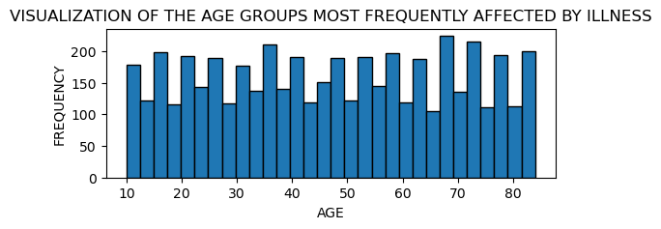

**CODE:**

custom_palette = {'Male': 'red', 'Female': 'purple'}

plt.figure(figsize=(6, 2))

sns.countplot(y='Gender', data=df, order=df['Gender'].value_counts().index, palette=custom_palette)

plt.title('GENDER DISTRIBUTION')

plt.xlabel('COUNT')

plt.ylabel('GENDER')

plt.show()

**DESCRIPTION:**

This code provides a graphical representation of the gender distribution within the dataset, allowing for easy comparison and interpretation of gender proportions.

**OUTPUT:**

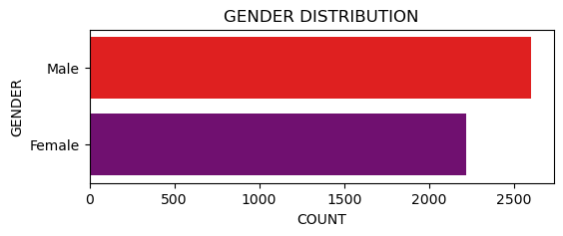

**CODE:**

plt.figure(figsize=(6, 4))

df['Blood Type'].value_counts().plot(kind='pie', autopct='%1.1f%%', colors=['red', 'blue', 'green', 'pink','purple','yellow','lightblue','lightgreen'])

plt.title('BLOOD TYPE DISTRIBUTION')

plt.ylabel('')

plt.show()

**DESCRIPTION:**

This code provides an intuitive visualization of blood type distribution, highlighting the relative proportions of different blood types within the dataset.

**OUTPUT:**

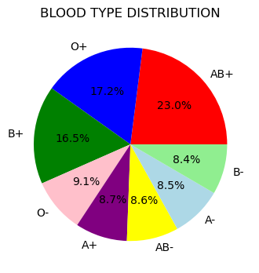

**CODE:**

plt.figure(figsize=(8, 7))

df['Disease'].value_counts().sort_values().plot(kind='barh', color='red')

plt.title('THE AGGREGATE COUNT OF INDIVIDUALS AFFLICTED BY A SPECIFIC ILLNESS.')

plt.xlabel('COUNT OF PEPOPLE')

plt.ylabel('LIST OF DISEASE')

plt.show()

**DESCRIPTION:**

This code offers a clear visual representation of the distribution of diseases and their respective frequencies within the dataset.

**OUTPUT:**

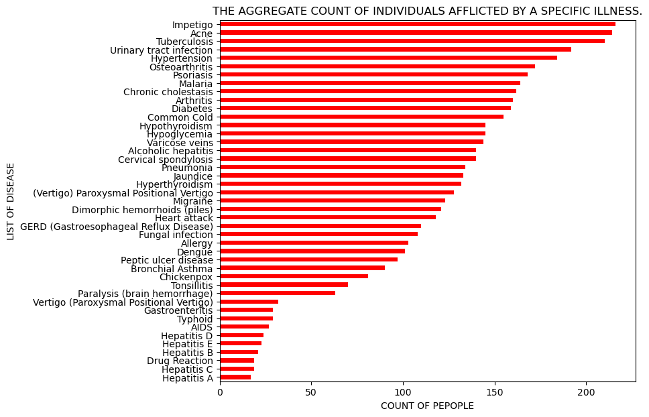

**CODE:**

plt.figure(figsize=(5, 3))

sns.countplot(x='Test Result', hue='Test Result', data=df, palette='pastel')

plt.title(' COUNT OF TEST RESULT')

plt.xlabel('TEST RESULT')

plt.ylabel('COUNT')

plt.show()

**DESCRIPTION:**

This code offers a graphical representation of test result counts, allowing for easy comparison and interpretation of different test outcomes.

**OUTPUT:**

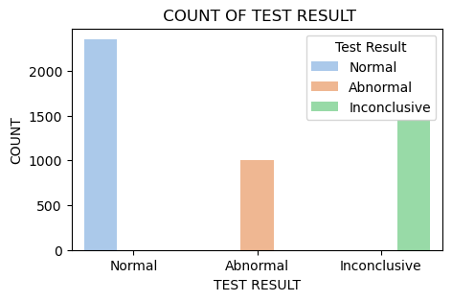

**DATA PREPROCESSING:**

**CODE:**

categorical_columns = ['Disease','Test Result']

numerical_columns = ['Age']

X = df[categorical_columns + numerical_columns]

y = df['Medication']

**DESCRIPTION:**

This code facilitates the segmentation of data into features and target variables, enabling the development of predictive models.

**CODE:**

preprocessor = ColumnTransformer(

transformers=[

('cat', OneHotEncoder(drop='first'), categorical_columns,)

],

remainder='passthrough'

)

X = preprocessor.fit_transform(X)

**DESCRIPTION:**

This code prepares the categorical features for machine learning models by encoding them into a numerical format while preserving the numerical features in the dataset.

**CODE:**

X_train, X_test, y_train, y_test = train_test_split(X, y, test_size = 0.3, random_state = 22)

**DESCRIPTION:**

This code facilitates the creation of separate datasets for training and evaluating machine learning models.

**DATA MODELLING:**

**DECISION TREE CLASSIFIER**

**CODE:**

classifier = DecisionTreeClassifier(random_state=22)

classifier.fit(X_train, y_train)

y_pred=classifier.predict(X_test)

accuracy = metrics.accuracy_score(y_test, y_pred)*100

print("Decision Tree Classifier")

print("Test Accuracy: {:.2f}".format(accuracy))

cv_scores = cross_val_score(classifier, X_train, y_train, cv=5)

print("CROSS VALIDATION FOR DECISION TREE CLASSIFIER")

print("CROSS VALIDATION SCORES:", cv_scores)

print("MEAN CROSS VALIDATION SCORE:", np.mean(cv_scores))

print("STANDARD DEVIATION OF VALIDATION SCORES:", np.std(cv_scores))

**DESCRIPTION:**

This code trains a Decision Tree Classifier model on the training data ('X_train' and 'y_train') and evaluates its performance on the testing data ('X_test' and 'y_test'). It calculates the accuracy of the model's predictions using the 'accuracy_score' function from scikit-learn. Additionally, it performs cross-validation with 5 folds on the training data using the 'cross_val_score' function to assess the model's generalization performance. The mean cross-validation score and the standard deviation of the validation scores are computed to provide insights into the model's stability and reliability.

**OUTPUT:**

Decision Tree Classifier

Test Accuracy: 97.86

CROSS VALIDATION FOR DECISION TREE CLASSIFIER

CROSS VALIDATION SCORES: [0.97037037 0.97333333 0.98666667 0.98962963 0.97777778]

MEAN CROSS VALIDATION SCORE: 0.9795555555555555

STANDARD DEVIATION OF VALIDATION SCORES: 0.007460550110823223

**RANDOM FOREST CLASSIFER:**

**CODE:**

classifier2 = RandomForestClassifier(random_state=22)

classifier2.fit(X_train, y_train)

y_pred_train =classifier2.predict(X_train)

accuracy = metrics.accuracy_score(y_test, y_pred)*100

print("Random Forest Classifier")

print("Test Accuracy: {:.2f}".format(accuracy))

cv_scores = cross_val_score(classifier2, X_train, y_train, cv=5)

print("CROSS VALIDATION FOR RANDOM FOREST CLASSIFIER")

print("CROSS VALIDATION SCORES:", cv_scores)

print("MEAN CROSS VALIDATION SCORE:", np.mean(cv_scores))

print("STANDARD DEVIATION OF VALIDATION SCORES:", np.std(cv_scores))

**DESCRIPTION:**

This code trains a Random Forest Classifier model on the training data ('X_train' and 'y_train') and evaluates its performance on the testing data ('X_test' and 'y_test'). It calculates the accuracy of the model's predictions using the 'accuracy_score' function from scikit-learn. Additionally, it performs cross-validation with 5 folds on the training data using the 'cross_val_score' function to assess the model's generalization performance. The mean cross-validation score and the standard deviation of the validation scores are computed to provide insights into the model's stability and reliability.

**OUTPUT:**

Random Forest Classifier

Test Accuracy: 97.86

CROSS VALIDATION FOR RANDOM FOREST CLASSIFIER

CROSS VALIDATION SCORES: [0.97333333 0.97481481 0.98814815 0.98814815 0.96888889]

MEAN CROSS VALIDATION SCORE: 0.9786666666666667

STANDARD DEVIATION OF VALIDATION SCORES: 0.00798352212462662

**K NEAREST NEIGHBOURS**

**CODE:**

classifier4 = KNeighborsClassifier(n_neighbors=5)

classifier4.fit(X_train, y_train)

y_pred=classifier4.predict(X_test)

accuracy = metrics.accuracy_score(y_test, y_pred)*100

print("KNN")

print("Test Accuracy: {:.2f}".format(accuracy))

cv_scores = cross_val_score(classifier4, X_train, y_train, cv=5)

print("CROSS VALIDATION FOR KNN")

print("CROSS VALIDATION SCORES:", cv_scores)

print("MEAN CROSS VALIDATION SCORE:", np.mean(cv_scores))

print("STANDARD DEVIATION OF VALIDATION SCORES:", np.std(cv_scores))

**DESCRIPTION:**

This code trains a K-Nearest Neighbors (KNN) Classifier model with k=5 on the training data ('X_train' and 'y_train') and evaluates its performance on the testing data ('X_test' and 'y_test'). It calculates the accuracy of the model's predictions using the 'accuracy_score' function from scikit-learn. Additionally, it performs cross-validation with 5 folds on the training data using the 'cross_val_score' function to assess the model's generalization performance. The mean cross-validation score and the standard deviation of the validation scores are computed to provide insights into the model's stability and reliability.

**OUTPUT:**

KNN

Test Accuracy: 54.73

CROSS VALIDATION FOR KNN

CROSS VALIDATION SCORES: [0.48888889 0.45481481 0.47555556 0.49333333 0.50222222]

MEAN CROSS VALIDATION SCORE: 0.482962962962963

STANDARD DEVIATION OF VALIDATION SCORES: 0.01649707959357043

**SUPPORT VECTOR MACHINES**

**CODE:**

classifier6 = SVC(random_state=22)

classifier6.fit(X_train, y_train)

y_pred=classifier6.predict(X_test)

print("Support Vector Machines")

print("Test Accuracy: {:.2f}".format(accuracy))

cv_scores = cross_val_score(classifier, X_train, y_train, cv=5)

print("CROSS VALIDATION FOR SUPPORT VECTOR MACHINES")

print("CROSS VALIDATION SCORES:", cv_scores)

print("MEAN CROSS VALIDATION SCORE:", np.mean(cv_scores))

print("STANDARD DEVIATION OF VALIDATION SCORES:", np.std(cv_scores))

**DESCRIPTION:**

This code trains a Support Vector Machines (SVM) classifier on the training data ('X_train' and 'y_train') and evaluates its performance on the testing data ('X_test' and 'y_test'). It predicts the target variable 'y_pred' using the trained model and calculates the accuracy of the model's predictions using the 'accuracy_score' function from scikit-learn. Additionally, it performs cross-validation with 5 folds on the training data using the 'cross_val_score' function to assess the model's generalization performance. The mean cross-validation score and the standard deviation of the validation scores are computed to provide insights into the model's stability and reliability.

**OUTPUT:**

Support Vector Machines

Test Accuracy: 54.73

CROSS VALIDATION FOR SUPPORT VECTOR MACHINES

CROSS VALIDATION SCORES: [0.97037037 0.97333333 0.98666667 0.98962963 0.97777778]

MEAN CROSS VALIDATION SCORE: 0.9795555555555555

STANDARD DEVIATION OF VALIDATION SCORES: 0.007460550110823223

**MODEL SELECTION:**

Upon examining the test accuracy and cross-validation scores, it becomes apparent that the utilization of decision tree classifiers offers advantages over other models such as random forest classifiers, K-nearest neighbors, and support vector machines. The decision tree classifier exhibits promising performance metrics, demonstrating its effectiveness in medication prediction tasks. In contrast, the other models may present limitations or complexities that hinder their performance compared to the decision tree approach. Therefore, for this specific dataset and task, the decision tree classifier emerges as the preferred choice due to its favorable performance characteristics. This conclusion underscores the importance of selecting the most suitable model based on the specific requirements and characteristics of the dataset and task at hand.

**STREAMLIT:**

st.set_page_config(layout="wide")

with st.sidebar:

st.title("Medication Recommendation System")

st.markdown(

"""

## About the Project

This is a Medication Recommendation System designed to provide personalized medication recommendations

based on user inputs such as age, gender, blood type, disease, and test results. Simply fill in the

required information and click the button to get your medication recommendation.

"""

)

with st.container():

st.subheader("User Inputs")

with st.form(key='my_form'):

age = st.slider("Age", min_value=1, max_value=100, value=30)

gender = st.radio("Gender", ["Male", "Female"])

blood_type = st.selectbox("Blood Type", ["A", "A-", "B", "B-", "AB", "AB-", "O", "O-"])

disease = st.selectbox("Disease", ["Acne", "Osteoarthritis", "Bronchial Asthma", "Alcoholic hepatitis", "Impetigo",

"Tonsillitis", "(Vertigo) Paroxysmal Positional Vertigo",

"Dimorphic hemorrhoids (piles)", "Tuberculosis", "Pneumonia", "Varicose veins",

"Hypothyroidism", "Heart attack", "Hypoglycemia", "Cervical spondylosis",

"Diabetes", "Common Cold", "Arthritis", "Hypertension", "Chronic cholestasis",

"Migraine", "Urinary tract infection", "Hyperthyroidism",

"GERD (Gastroesophageal Reflux Disease)", "Allergy", "Chickenpox", "Dengue",

"Psoriasis", "Malaria", "Fungal infection", "Jaundice", "Hepatitis A",

"Paralysis (brain hemorrhage)", "Peptic ulcer disease",

"Vertigo (Paroxysmal Positional Vertigo)", "Hepatitis B", "Gastroenteritis",

"Typhoid", "AIDS", "Hepatitis E", "Drug Reaction", "Hepatitis C", "Hepatitis D"])

test_result = st.selectbox("Test Result", ["Normal", "Abnormal", "Inconclusive"])

submit_button = st.form_submit_button(label='Get Recommendation', help='Click to get medication recommendation')

if submit_button:

input_data = pd.DataFrame({

'Age': [age],

'Gender': [gender],

'Blood Type': [blood_type],

'Disease': [disease],

'Test Result': [test_result]

})

input_data_encoded = preprocessor.transform(input_data)

medication = classifier.predict(input_data_encoded)

st.subheader("Recommended Medication")

st.write(medication[0])

**OUTPUT:**

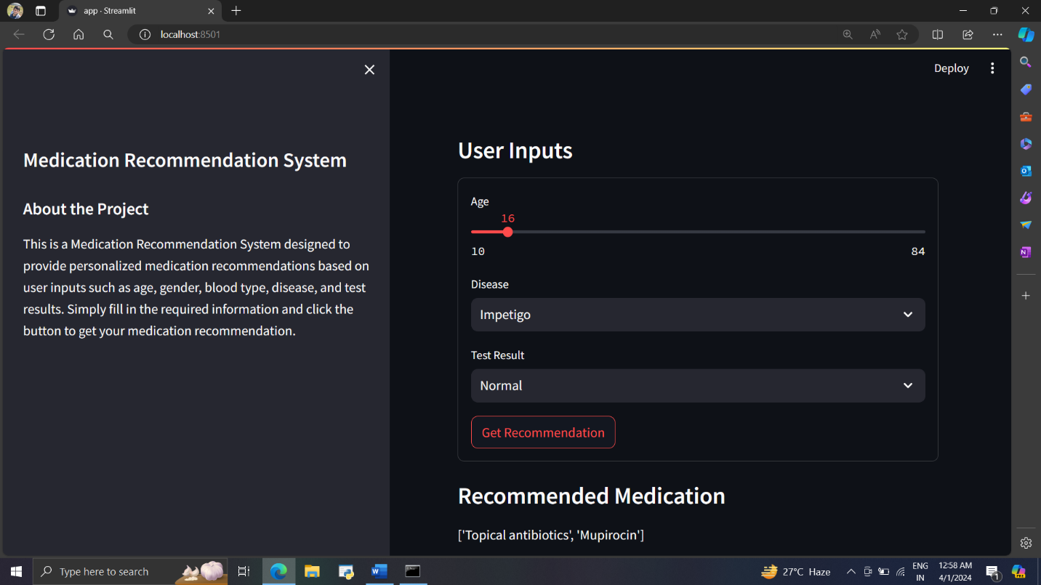

**GITHUB LINK:**

<https://github.com/Meenalosani/MediMapper>